**Store vars in linux : placing them into the ~/.** **bashrc file, ~/.** **profile , or whichever startup file you use for your default shell**.

**Zombie Process : processes that have completed their execution, but their entries are not removed from the process table**.

## Top, htop - View Running Processes in Linux

Ps- List the process

Kill -l

1) SIGHUP 2) SIGINT 3) SIGQUIT 4) SIGILL 5) SIGTRAP

6) SIGABRT 7) SIGBUS 8) SIGFPE 9) SIGKILL 10) SIGUSR1

11) SIGSEGV 12) SIGUSR2 13) SIGPIPE 14) SIGALRM 15) SIGTERM

**kill -9 `pgrep ping` or pkill -9 ping**

#### First field – The block device / dev/xvda

#### Second field – The mountpoint /data

#### Third field – The filesystem type /ext3

#### Fourth field – Mount options defaults, rw, suid, dev, auto, nouser, async

#### Fifth field – Should the filesystem be dumped

#### Sixth field – Fsck order

Netstat : Netstat is a command-line network utility used to **display network connections for the TCP/UDP**, network protocol statistics, interface statistics, routing tables, masquerade connections, multicast memberships e.t.c. netstat program is obsolete now and its replacement is **ss.**

+++++++++++++++++++++++++++++++++++

**ss command**is a tool used to dump socket statistics and displays information in similar fashion (although simpler and faster) to netstat.

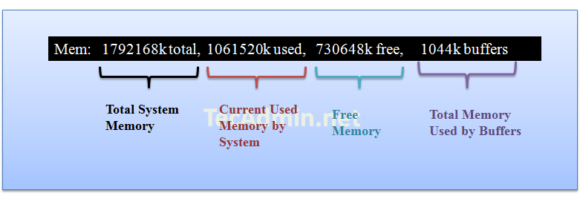

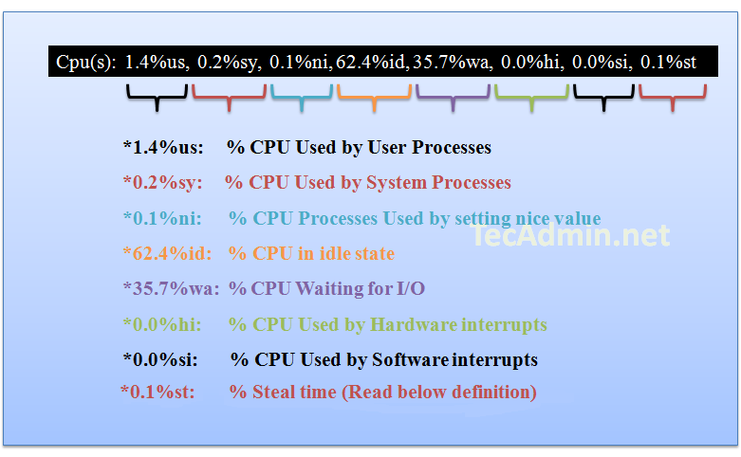

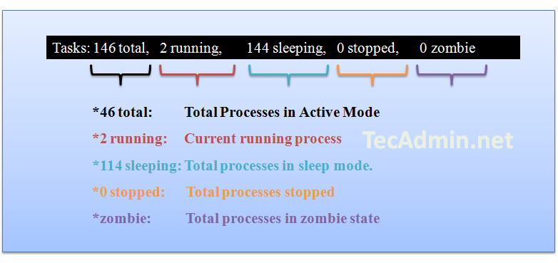

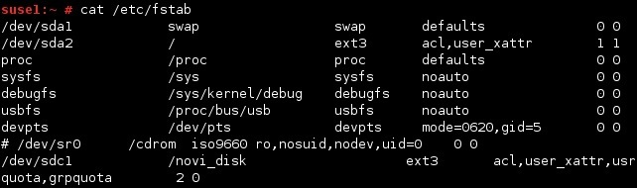

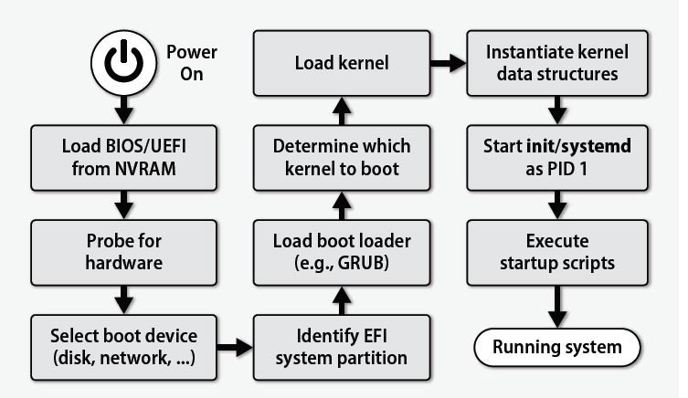

**API SERVER:** This is the Frontend of K8, It manage Users, devices, cli coordination etc.

**ETCD:** it is key store, It is db of K8 where store its info

**Scheduler:** It distribute containers on nodes, It create containers & assign to nodes

**Controller:** If container goes off / hand or not responding this controller takes dicision and reply that we need to create new container or not.

**Kublet :**  It’s a agent that runs on every node, this tells us that the container is running or not  
**Container runtime:** the container runtime is the underlying software that us used to run container like docker. RKT.io

**Kube Proxy :** It used to enable connectivity parts, services across different nodes in the cluster.

**Kubectl Proxy :** Is an HTTP proxy service create by kubectl utility to access the kube api server.

**Replication Controller :** provide facility to **create multiple pods, and make sure that that number of pods always exists**. If a pod does crash, the Replication Controller replaces it.

**Replicaset** : A ReplicaSet's purpose is to maintain a **stable set of replica Pods running** at any given time.

**Deployment** : A Deployment **provides declarative updates for**[**Pods**](https://kubernetes.io/docs/concepts/workloads/pods/)**and [ReplicaSets](https://kubernetes.io/docs/concepts/workloads/controllers/replicaset/" \o "" \t "_blank)**.

**Labels** : are **key / values that are attached to oabjects** such as pods. Labels can be used to organize and to select subset of objects.

**Selector** : Via a lebel selector , client / user can **identify a set of objects** the label selector is a **core grouping primitive** in k8

**Stateful and Stateless:** **stateless applications don’t “store” data**.

**stateful applications** require backing storage/presistant data store.

**Ingress** is incoming traffic to a pod. **Egress** is the outgoing traffic from pods.

**Kube Certi API** : / var/lib / kubernites / ca.pem, Kubernetes.pem, .key

**Static Pods :** create by kubelet, Deploy control plain components asstatic pod, Ignored by Kube scheduler.

**Cordan** : mark as unschedulable

**Tolerations** allow the scheduler to schedule pods with matching taints.

**Taints** are a property of nodes that push pods away if they are not tolerate to node taint.

**Node affinity** makes sure that pods are scheduled in particular nodes.

**Affinity** :**required/preferred** during scheduling **ignored/required** during execution

**Heapster** is a cluster-wide aggregator of monitoring and event data.

Configmap store in plain text and secrets store in base64.

**Pod eviction time :** if pod down from last 5 min then controller create new this time

**Node draining** is the mechanism that allows users to gracefully move all containers from one node to the other ones.

**A DaemonSet** ensures that Nodes run a copy of a Pod.

**RBAC,** Role-based access control, is an authorization mechanism for managing permissions around Kubernetes resources.

**Static Provisioning :** We create disk ( PV ) persistent volume then we create Persistent volume claim is called static provisioning

**Dynamic provisioning** : We not need to create PV when we create PVC it crate disk automatically on gcp a/ws and claim disk space automatically.

**recreate**: Delete the Old and then create new pods

**ramped**: rolling update one by one create and down

**blue/green**: Keep dual resources, create new all then down old

**canary**: For some users only if success then further or rollback

**a/b testing:** Suitable for change frontend application. Used for moduler.

Entrypoint and cmd both used for run command, entry point can be one and cmd multiple and cmd can overwrite entrypoint

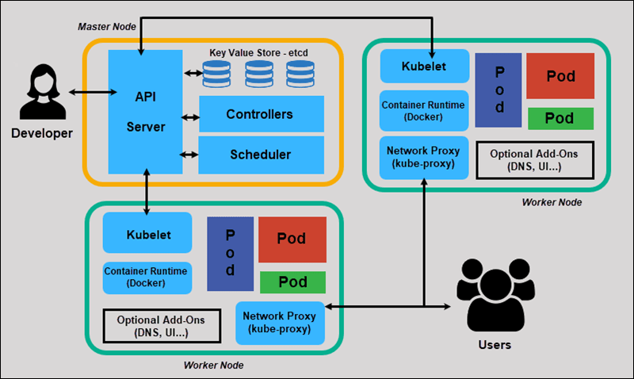

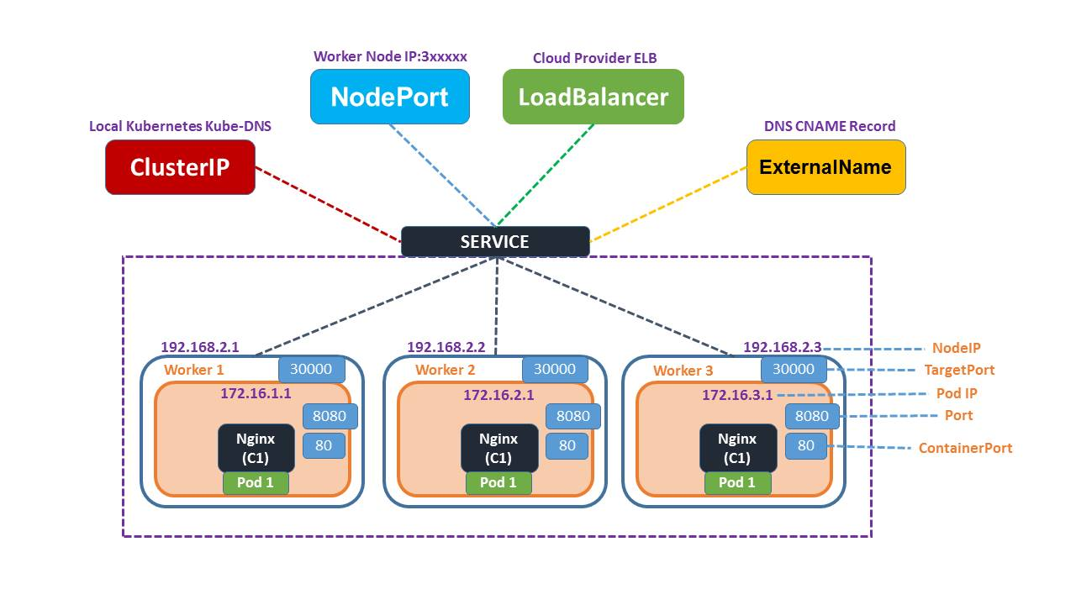

Role : A role is a collection of tasks, files, templates, and variables organized in a standardized way to perform a specific function or configure a specific component.

Task is a set of instructions

Handlers are executing when any specific change happen in system like system restart.

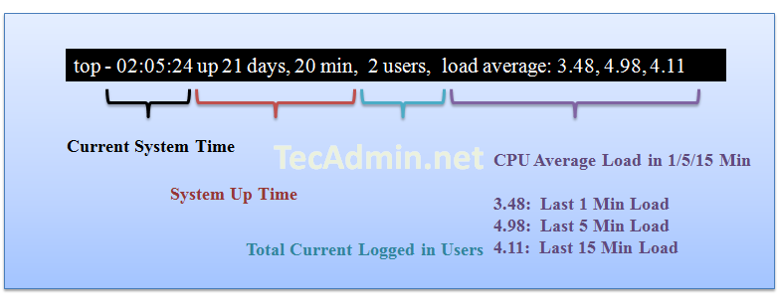

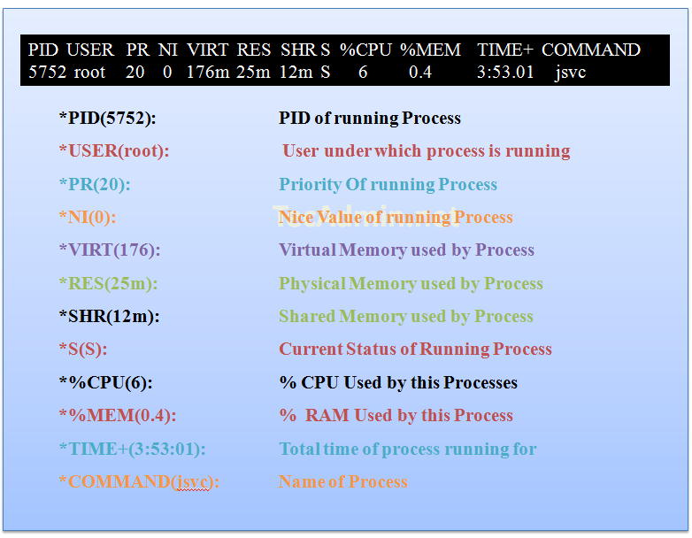

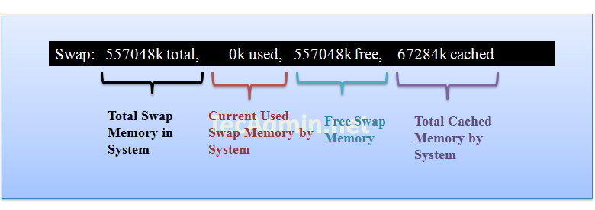

**Keep and 3 projects in your hand to tell to interviewer**

**Keep any 3 troubleshooting in your hand to tell to your interviewer.**